**FINAL WRAP-UP REPORT**

Online Portfolio

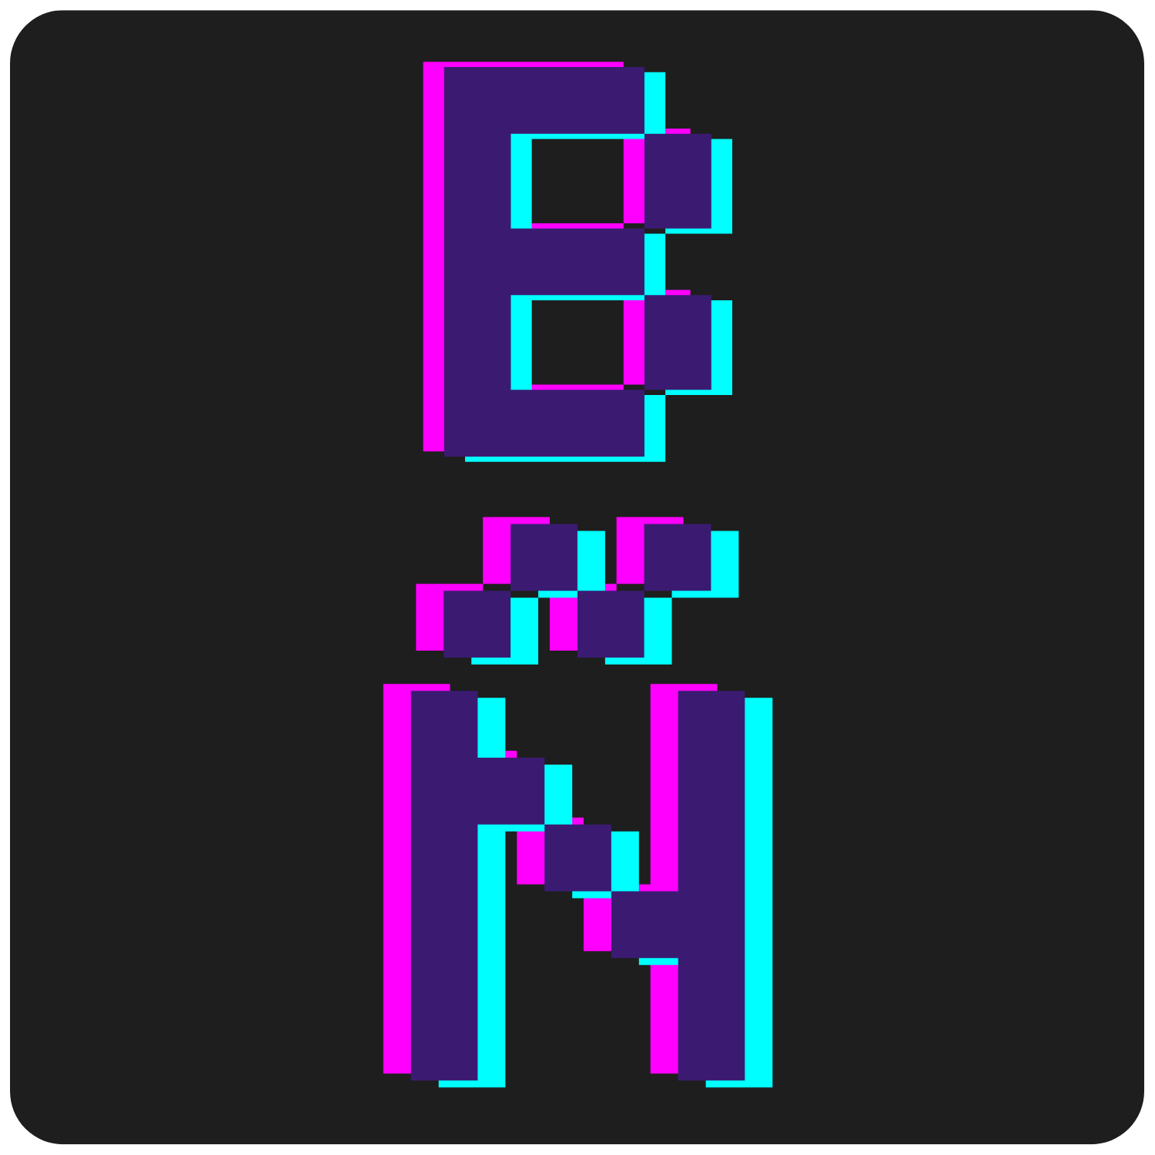

Bryan Nuñez

WDD130-09

December, 2022

**Introduction.**

**Subject.**

This site will be my online portfolio. This is a space where I can share my work, projects and skills in coding for future employment opportunities. Also, this would help me to show my work to customers who are interested in having a website.

Some of the projects will be focused on a specific skill. For example, some projects could be focused on design and other projects in development.

**Target Audience.**

The audience will be recruiters that are interested in hiring a web designer and developer. Also, people or businesses who are looking for a developer to create tools for their businesses. My target is people who’s looking to hire a developer to work on a company or for a project. I plan to become a full-stack developer.

Due to mostly of my audience will be recruiters because I will apply for many jobs, they will access my portfolio on a computer so that they can take a look at my code. Nevertheless, the website must be fully responsive to mobile devices.

**Website URL.**

<https://ibryanunez.github.io/wdd130/portfolio/index.html>

**Objectives.**

My main goal with this website is to get a job as a Junior Developer next year. Once I complete my certificate in Web and Computer Programming, I will apply for Junior Developer jobs.

This is the first version of my portfolio, but I will improve it as I develop more skills as I continue with my education. As I get involved in school projects and projects that I get paid for, I will post and share my work to continue with my career as a web designer and developer.

**Design Process.**

I wanted my portfolio to look like a text editor and also to make it look like arcade games. The fonts and colors that I chose remind of arcade video games such as Space Invaders or Pacman and to a programming text editor.

I wanted that the logo would wrap the arcade style, coding style and me. I wanted something simple. I decided to use my name initials, but I thought that if I added an “ñ” instead of an “n” because my last name has one and the “ñ” would make it look more unique.

The color palette I wanted to make it look like the color of the fonts of my text editor. So I used the same color patterns in the design of the color palette in website.

I wanted the fonts to look like the font of the text editors and also to look like an arcade videogame. So, I looked for fonts that would look like that.

It was hard to find images that would match the color palette and the arcade or bitmap style that I wanted in my website, so I designed my own social media icons, and all the arcade or pixel images. That was one of the parts that took longer time. But I was able to design good images with the arcade style and my color palette.

As I was looking for inspiration for my portfolio, I took a look at other portfolios to have an idea of how to design it. Also, I looked at many other kinds of websites to get inspiration. One of them, was Apple’s website. I liked how the used the blur effect in their navigation bar and in other parts on their website and I wanted to use some blur effects like those in my portfolio as well.

**Conclusion.**

After completing this project, I applied the knowledge and skills that I’ve learned during this course. Also, I was able to learn more things that were not in this course and this experience has helped me to know that I can be a web designer and developer. I feel ready and excited to learn and improve my coding skills and to keep preparing to become a full-stack developer.

As I learn and improve my skills, I will improve my portfolio as well to accomplish my goals.